Movie: “La vida que te espera”
A cultural landscape: la “Pasieguería”

INSTRUCTIONS
The movie “La vida que te espera” (on a free translation, “the life ahead of you”) was shot in some valleys of Cantabria, “los valles pasiegos”, during the year 2004. It is a rural drama but includes cultural and anthropologic resemblances of the traditional life of that area and the impact of the social and economic transformations of Cantabria on such style of life.

Once you have watched the film, answer the following questionnaire. You can include the graphic material (pictures, maps, etc) that you consider appropriate, but remember to cite their origin.

This essay should not exceed 1,000 words.

Exercise 1: provide a short synopsis of the movie.
http://es.wikipedia.org/wiki/La_vida_que_te_espera
www.filmaffinity.com/es/film812560.html

Exercise 2: The geographical location of the story and the impact of the physical environment on the human activities
In the attached map, locate and draw the three valleys conforming the region of the Pasieguería | 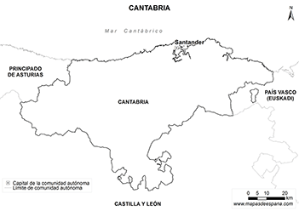
The outdoor scenery (landscape) of the movie. Mention, at least, 3 elements of the physical environment which may become conditioning factors of the human activities in the study area. Besides, if it is possible, which are the adaptation responses of the people to those conditioning factors.

Exercise 3: Ethnography
The rural people of the movie are called “Pasiegos”. Mention, at least, 2 Stereotypes of the “Pasiegos” behavior mentioned in the movie.

“Pasiegos” have their own popular “sports”. Make short research in Internet and describe briefly one of them.

Exercise 4: The traditional economic and social system
The traditional economic system is based on:

What is the meaning of the word “muda”.

¿Where are located the spaces called “brañas”? Which is their utility?

Explain if the system is based on an intensive or extensive use of manpower and which are the consequences on the personal life of the “pasiegos”.

Exercise 5: The architecture of the houses
Describe and analyze the main features of the traditional buildings.

Relate those characteristics with the environment and the principal activities of the “pasiegos”.

Explain the meaning of the concept “cabañas vividoras”

Exercise 6: The influence of the “modern world” in the traditional way of life “pasiego”
The migration from rural to urban areas: reasons and consequences.

Research task: which were the consequences of the adhesion of Spain to the EU for Cantabria´s rural areas?

